Course: CSN 405 – Network Programming
LAB 4 – Multi Threading

Student name | Phan Ngọc Hạnh Nhi
Student ID | 2131209002

Question 1
Write a Python program that implements a TCP server and a client. Each client should:
- Send a message to the server.
- The server should reverse the message, convert it to uppercase, and append the client's IP address and port to the response.
- Send the processed message back to the client.
Requirements:
- The server should log the communication details (client IP, port, and message exchanged).
- The client should display the server's response and exit gracefully.
Example Communication:
- Client sends: "hello world"
- Server responds: "DLROW OLLEH (127.0.0.1:12345)"

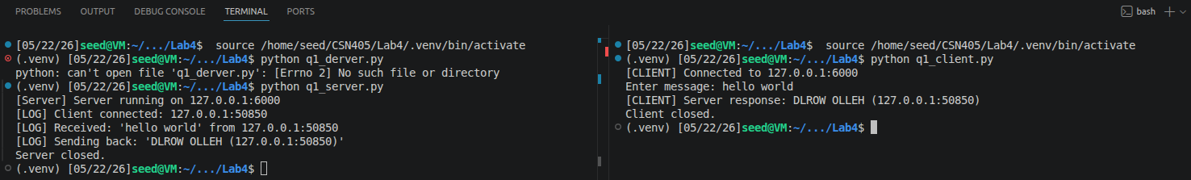
Question 2
Design and implement a Client-Server system that uses TCP sockets to do the following:
Client identification:
- When the Client starts, it connects to the Server.
- The Client sends its name to the Server (for example: Client1).
- The Server stores the following information for the entire session:
- Client name
- Client IP address
- Client port number

Client side:
- After sending its name, the Client enters an infinite loop.
- In each loop, the Client reads a line of input from the user.
- The user input must be in the following format:

number operator number

Ex: | 13 + 7 | 3.24 - 45 | 4.5 / -6

- If the input format is invalid, the Client displays a warning message.
- If the input format is valid, the Client sends the input string to the Server.

Server side:
- The Server runs in an infinite loop waiting for messages from the Client.
- When a request is received, the Server:
- Prints the received message
- Performs the requested arithmetic operation
- Sends the result back to the Client as a string
- The Client displays the results received from the Server.

Example Communication:
Server side:
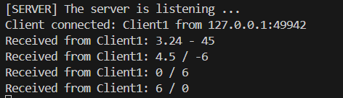
Client side:
- Valid:
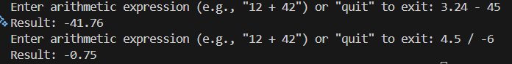
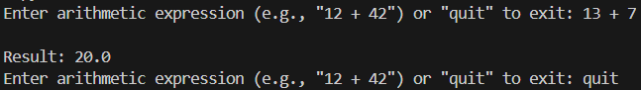
- Invalid:
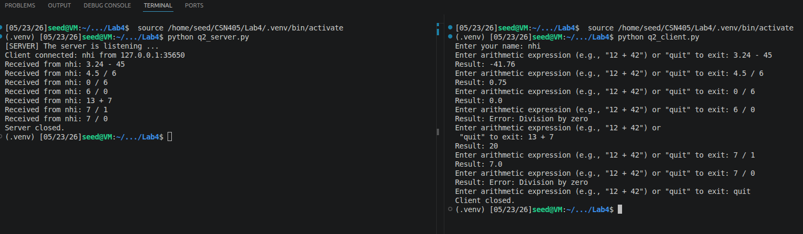
Question 3:
Extend the system from Question 2 so that the Server can handle multiple Clients at the same time.
- The Server must use multi-threading.
- Each Client connection (via TCP socket) is handled by a separate thread.
- For every connected Client, the Server provides the same service described in
  - Receive client name (id)
  - Process arithmetic requests
  - Send results back to the correct Client
Students must:
- Briefly explain your code
- How multi-threading works in this case

Hint:
while True:
#Each accept creates a new conn socket for the client.
conn, addr = server_sock.accept()
t = threading.Thread(target=handle_client, args=(conn, addr), daemon=True) t.start()

handle_client: function send and receive the data
Example Communication:
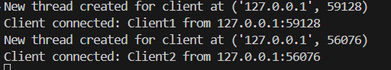

Result:

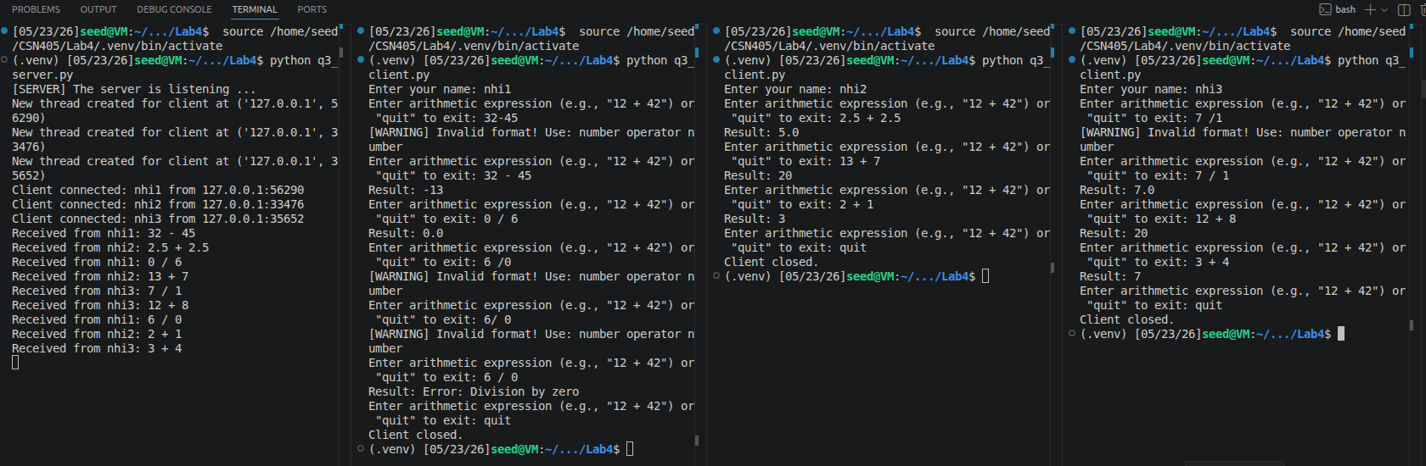
Question 4: TCP True/False Quiz using multi-threading for multiple clients
Server Implementation
Create a TCP server that listens to localhost, port 5050.
Prepare a list of at least 3 True/False questions:
- “Port 80 is used for HTTP.”
- “TCP is a connection-oriented protocol.”
- “UDP guarantees delivery of packets.”
- “Socket needs a tuple HOST and PORT”
- “IPv4 is the only IP can be assigned for computer”

When all questions are answered: send “Quiz finished!” to client
If the client sends quit or exit, the server should close the connection

When a client connects:
- Send the quiz questions to the client one by one
- For each question:
  - Receive the client’s answer (“true” or “false”)
  - Check whether the answer is correct
  - Send one of the following responses:
    - “Yes, it’s correct!” if the answer is correct
    - “No, it’s wrong!” if the answer is incorrect

Client Implementation
- Connect to the server on localhost, port 5050
- Receive each question from the server
- Prompt the user to enter “true” or “false”
- Send the answer to the server
- Display the server’s response
- Continue until all questions are finished or the user enters “quit” or “exit”

Note: using threading for handle multi clients

